1. Installing XmlTool

1、Open xmltool (2020.1201). Exe for installation；

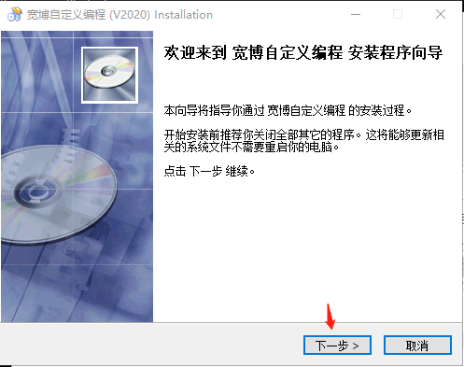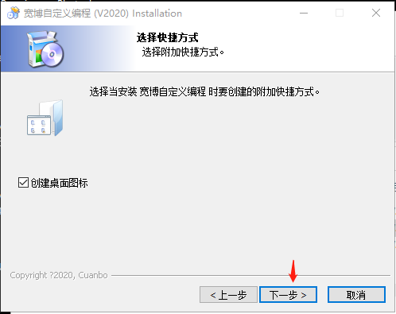

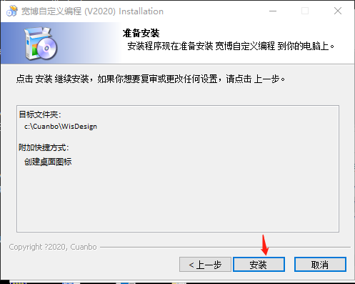

1. After installation, the "Cuanbo custom programming" icon appears on the desktop 
2. Software tools for using
3. Open the project file, file - > Open Project - > select "demo. CBC" project file

2、Self defined interface project, main interface；

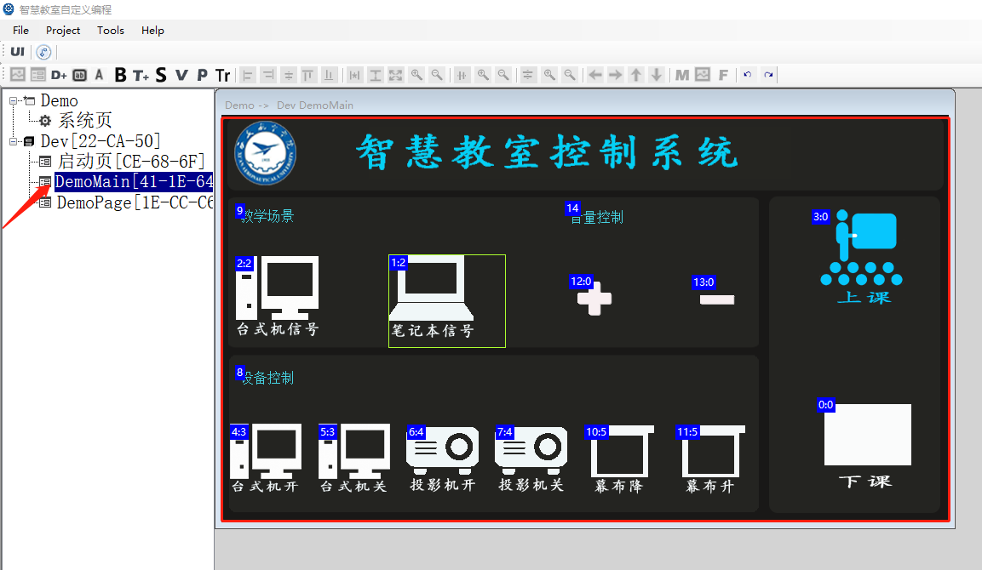

3、Add picture material；

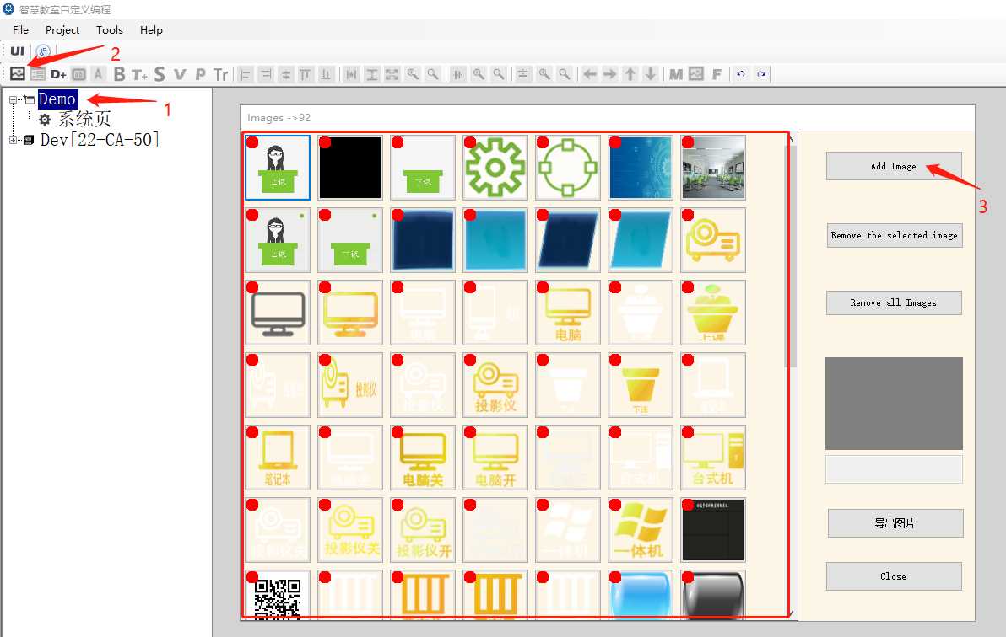

1. Set the background. Double click “demomain” to display the setting item - > set the background and select the material；

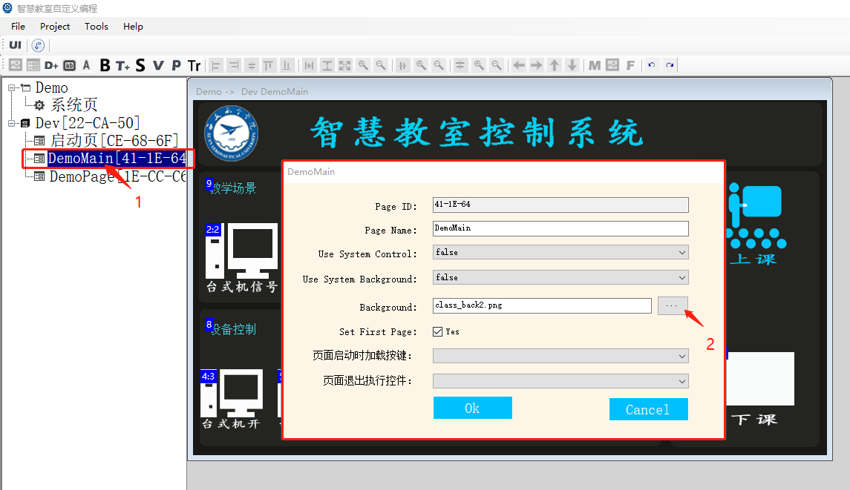

1. o add a key, click the T + icon to add a key to drag the position freely

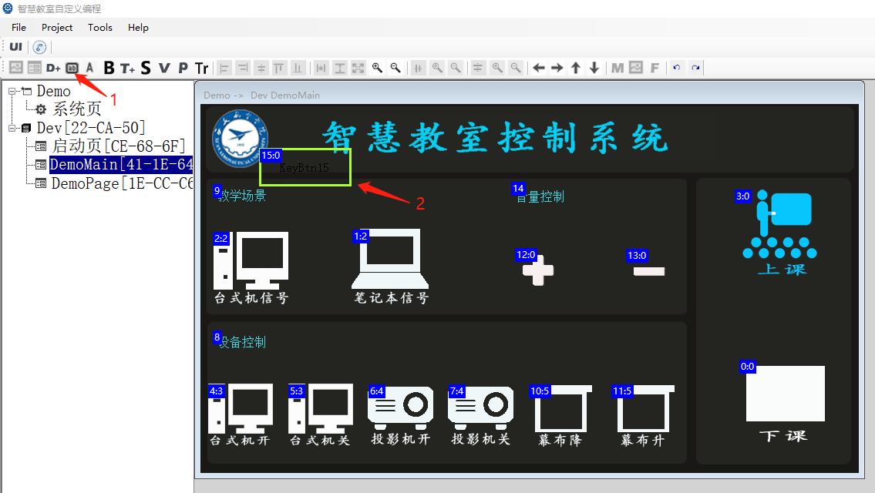

1. Configure button. Double click the button to configure button font, color, picture, position, size, key code and other settings

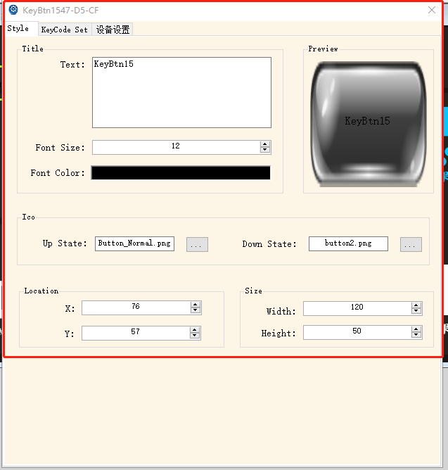

1. Compile the project, click Project - > Update Project - > build, and the XML file generated by compilation is in the directory "C: \ cuanbo \ wisdesign \ build";

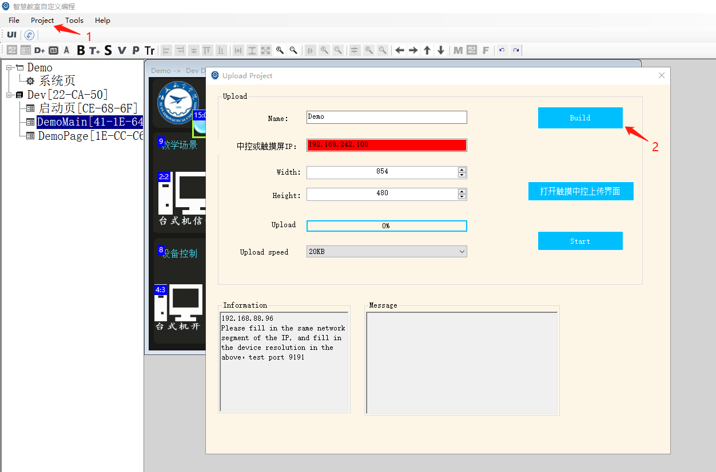

1. Upload the project in the web background system - > system update. After the upgrade is completed, click start app to automatically enter the XML interface;

